Machine Learning Lab Assignment

#### (Provide your code snippets. You may answer the questions with screenshots if applicable.)

**●** - 1 per group

## Explore Microsoft Cognitive Services

Navigate to the <https://azure.microsoft.com/en-us/services/cognitive-services/directory/> page and browse through the available Cognitive Services. There are services for Vision, Speech, Language, Knowledge, and Search.

Find one of the services that is interesting to you. For this part of the lab, you will need to try out the service. (I recommend that you do not select a service from the Knowledge or Search categories.)

There are two ways to try the service:

1. Click “Demo” beside the service description and then use the site to upload your own data. (This is the easy way out…)
2. Actually call the API. This will require that you setup an API Key via the Portal and then call the API from some language. (For example, using the [Python](https://docs.microsoft.com/en-us/azure/cognitive-services/) Quickstart.)

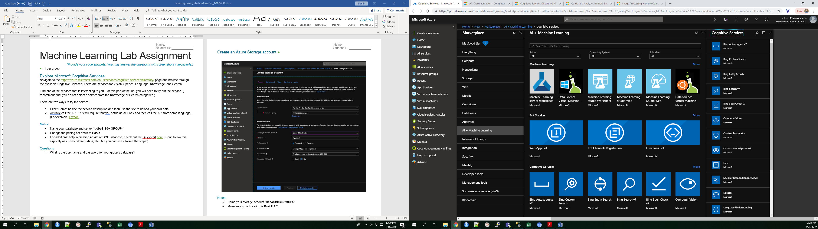

#### Questions

1. What service are you choosing to try out?
2. What data are you sending to the API? (For example, what is the picture, text, or audio file of?)
3. What was the response from calling the API? (Please paste in the full output or JSON response.)
4. Discuss the response. Is there anything that is surprising? Did the service do a good job?
5. Look at the Pricing Calculator for Cognitive Services. How much would your service cost if you needed to make ~25,000 API calls/transactions per month?

## Create an Azure Machine Learning Service Workspace **●**

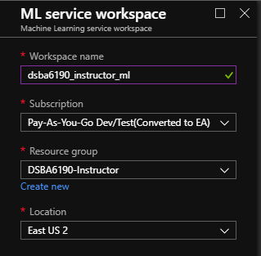

#### Notes:

* Name your service `**dsba6190_<GROUP>_ml**`
* Make sure your Location is **East US 2**.

## Use Automated Machine Learning

In your Azure Machine Learning service workspace that your group just created, use AutoML to create a machine learning model for a use case of your choosing.

There are multiple ways to use AutoML with AMLS: Through the portal, through Notebook VMs, locally using the Python package, and more.

Pick a machine learnable dataset. You can use a dataset that you’ve used in the past, a dataset from Kaggle or other public sources, etc. You’ll use this dataset for the rest of the assignment.

## Using AutoML from the AMLS GUI

You can use AutoML from the GUI in the Azure Portal:

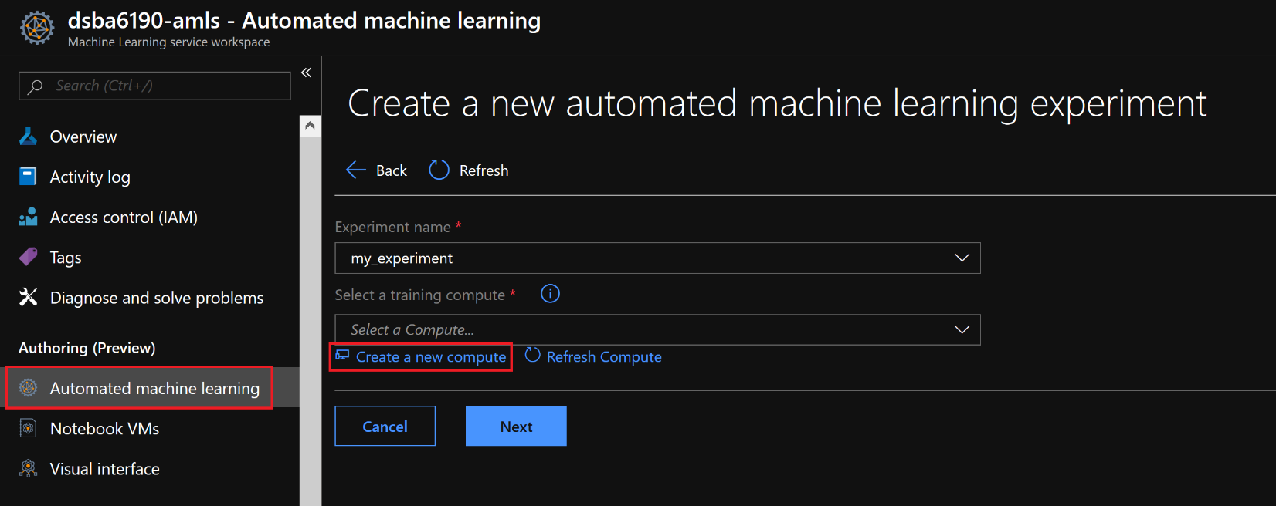

You’ll need to create a compute if your workspace doesn’t already have one. If someone in your group has already created one, multiple people can use the same one. Make sure you choose the **STANDARD_DS12_V2** VM size.

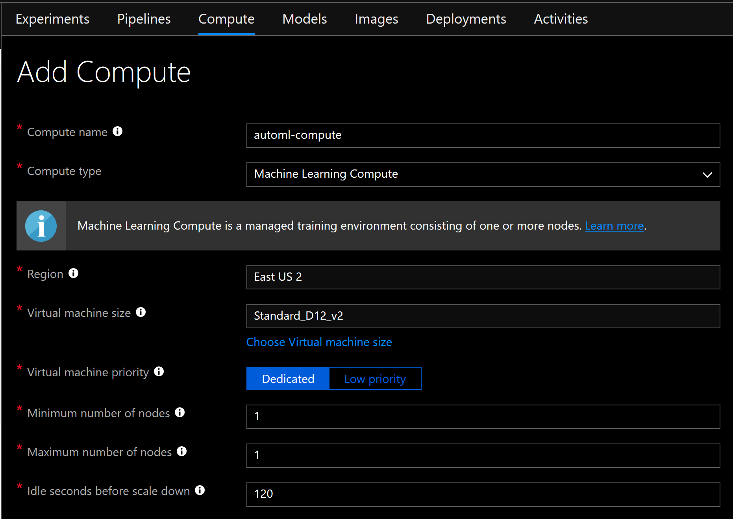

You can now upload your .csv file of your training data, pick the columns you’d like to use, pick the target variable (the dependent variable), the prediction task (classification, regression, or forecasting), primary metric, etc. and click **Start** to begin training.

#### Notes:

* Set **Training job time** to 60.
* Set **Max number of iterations** to 20.
* Check the **Preprocessing** checkbox.
* Set **Validation type** to K-fold cross validation
* Set **Number of Cross Validations** to 5.
* Set **Max concurrent iterations** to 1.

## Using AutoML from your local machine

You can use AutoML from your local machine using the azureml.train.automl Python library.

See the [documentation](https://docs.microsoft.com/en-us/azure/machine-learning/service/how-to-configure-auto-train) and [sample code](https://github.com/colbyford/DSBA6190-CloudComputing/raw/master/3%20-%20Machine%20Learning/lab/AutoML_Local_to_AMLS_SampleScript.py) to get started.

#### Questions

1. How are you using AutoML? (From the AMLS GUI or Locally)
2. Describe your dataset that you are using to train a model. Is this a classification, regression, or forecasting problem?
3. Which primary metric did you choose? Why?
4. After 20 iterations, how did AutoML do? Which model was the best?
5. Screenshot the iterations vs. metrics plot and paste below.
6. Let’s assume you used a single D12 v2 VM for your model training. How much did this cost? (Hint: Find the cost per minute of the D12 v2 and find out how many minutes your training experiment took to complete.)